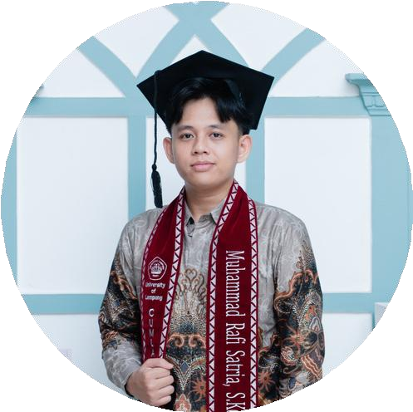
MUHAMMAD RAFI SATRIA

Bachelor of Computer Science

PROFILE SUMMARY
mrafisatria@gmail.com
+62 851 5511 7849
Muhammad Rafi Satria
https://mrafisatria.vercel.app

Bachelor of Computer Science with experience in full-stack web development and troubleshooting networks, CCTV systems, software, and hardware. Skilled in both front-end and back-end technologies, I am eager to contribute to a professional environment that fosters continuous growth and learning.

EDUCATION
University of Lampung 2021 - 2025
Bachelor of Computer Science
GPA: 3.72 of 4.00
Undergraduate Thesis: “Implementation of the Extreme Programming Method for Developing Academic Data and Learning Modules in a Web-Based Academic Information System Using the CodeIgniter 4 Framework at SMPN 29 Bandar Lampung”
SMA Negeri 5 Bandar Lampung 2018 - 2021
Science Major

SKILLS

Technical Skills: JavaScript, React.js, Next.js, Tailwind, Bootstrap, Node.js, Express.js, Laravel, PHP, MySQL, HTML, CSS, Figma, C++, Microsoft Office, CodeIgniter 4, Appsmith, Baserow, Claude AI, ChatGPT.
Soft Skills: Teamwork, Communication, Problem Solving, Critical Thinking, Adaptability, Time Management, Public Speaking, Customer Service, Continuous Learning.

PROFESSIONAL EXPERIENCE

Teaching Assistant | Department of Computer Science, University of Lampung
Lecturer: Rizky Prabowo
Assisted in teaching the Web Programming course by supporting lecture delivery, guiding students during coding practice sessions, managing course materials, and evaluating web-based assignments and final projects.
Feb - June 2024

Internship | Regional Financial and Asset Management Agency of Lampung Province Dec 2023 - Feb 2024
Supervisor: Nuraya Andayani (Head of the Treasury Subdivision)
Assisted in managing regional expenditure data through the SIPPKD application and developed the Physical Special Allocation Fund Information System (SIDAK) to manage and monitor Physical Special Allocation Fund (DAK Fisik) data.
IT Staff | Kosasih Medika Lampung Dec 2025 - May 2026
Mentor: Dzulfi Alauddin Hafidz (IT Staff)
Developed internal company systems to support the operations of 10 clinics. Performed troubleshooting for networks, CCTV systems, software, and hardware to ensure the optimal performance of systems and IT infrastructure.

FEATURED PROJECTS

Kosasih Medika SATUSEHAT Dashboard | SATUSEHAT Integration Website 2026
Fullstack Developer
Developed a SATUSEHAT integration dashboard for Kosasih Medika Clinic to streamline the monitoring and management of healthcare service data. The system facilitates data integration, monitors data submission status, and supports the digitalization of clinical services.

Clinic Commission Calculator for Kosasih Medika Lampung | Incentive Calculation Website 2026
Fullstack Developer
Developed a commission calculation system for Kosasih Medika Lampung to automate and improve the accuracy of employee commission calculations. The system streamlines performance monitoring, accelerates commission reporting, and enables efficient incentive data management.

Loyal Patient Dashboard for Kosasih Medika Clinic | Loyal Patient Monitoring Website 2026
Fullstack Developer
Developed a loyal patient monitoring dashboard for the Digital Marketing team at Kosasih Medika Lampung. The system enables tracking of loyal patient data and visit activity while supporting data analysis and marketing strategies to improve patient retention and engagement.

Online Attendance System for Kosasih Medika Lampung | Web-Based Attendance System 2026
Fullstack Developer
Developed an online attendance system for Kosasih Medika Clinic to streamline employee attendance tracking through a digital, real-time platform. The system improves attendance data accuracy, simplifies attendance monitoring, and accelerates reporting and workforce data management.

Online Reservation System for Kosasih Medika Lampung | Web-Based Reservation System 2026
Fullstack Developer
Developed an online reservation system for Kosasih Medika Clinic to enable patients to book appointments online. The system improves service efficiency, streamlines administrative processes, and simplifies reservation management for clinic staff.

Skycast | Weather Information Website | (https://skycastid.vercel.app) 2025
- Frontend Developer
- Developed a weather information website that provides real-time weather data for multiple cities, including temperature, humidity, atmospheric pressure, and wind conditions. The application enables users to monitor weather quickly and accurately through an interactive interface that adapts to current weather conditions.
Portfolio | Personal Portfolio Website | (https://mrafisatria.vercel.app) 2025
- Fullstack Developer
- Developed a personal portfolio website to showcase projects, professional experience, and technical skills. The website demonstrates expertise in web design, development, and the practical application of modern web technologies.
SIAKAD SMPN 29 Bandar Lampung | Undergraduate Thesis Project 2025
- Fullstack Developer
- Developed a web-based Academic Information System consisting of four main modules: Academic Data, Learning, Public Information, and Evaluation. The system improves administrative efficiency and provides students, staff, and stakeholders with easier access to academic services.
SIDAK (Physical Special Allocation Fund Information System) | Internship Project 2024
- Fullstack Developer
- Developed a web-based information system to manage and monitor Physical Special Allocation Fund (DAK Fisik) data. The system improves data accessibility and transparency for government staff and other stakeholders.
Dermaone | Bangkit Academy Capstone Project 2024
- Backend Developer
- Developed a web application integrated with a machine learning model to identify various skin diseases from uploaded images. The system analyzes user-submitted images and generates predictions based on a trained medical dataset, supporting early detection and teledermatology services.

ORGANIZATIONS AND COMMITTEES

Computer Science Department Expo | Pro Evolution Soccer Competition Secretary Coordinator 2023
- Assisted in coordinating all aspects of the Pro Evolution Soccer (PES) competition by supporting the coordinator in planning, organizing, and overseeing the event to ensure its successful execution.
Job Interview Workshop | Event Coordinator 2022
- Coordinated all aspects of the Job Interview Workshop, including planning, organizing, and supervising the event to ensure its successful execution.
Computer Science Student Association (HIMAKOM) | Scientific Affairs Member 2022
- Responsible for organizing academic training sessions and workshops to prepare participants for competitions and enhance their knowledge in relevant fields. Coordinated project exhibitions to showcase projects developed by Computer Science students.

LANGUAGE

Indonesian
- Native Speaker

English
- TOEFL: 523

